**Project Design Phase**

|  |  |
| --- | --- |
| Date | 29 June 2025 |
| Team ID | LTVIP2025TMID50749 |
| Project Name | Visualizing Housing Market Trends: An Analysis  of Sale Prices and Features using Tableau |
| Maximum Marks | 2 Marks |

Problem – Solution Fit

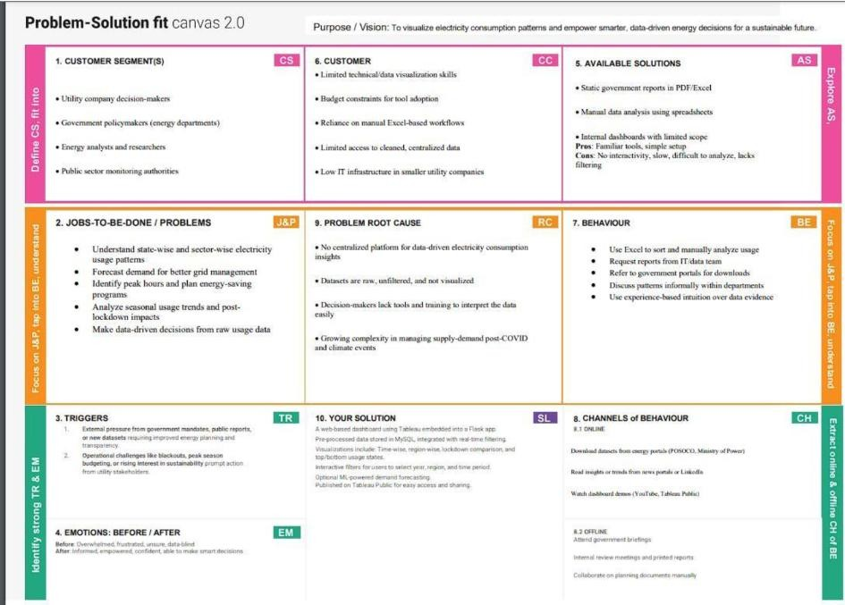

References:

1. <https://www.ideahackers.network/problem-solution-fit-canvas/>
2. [https://medium.com/@epicantus/problem-solution-fit-canvas-aa3dd59cb4fe](https://medium.com/%40epicantus/problem-solution-fit-canvas-aa3dd59cb4fe)